

|  |
| --- |
| About us |
| Find out what we do and how to make a complaint |

We strive for fair and positive change in the regulation of registered health practitioners for the Australian community.

Our primary role is to oversight bodies in the National Registration and Accreditation Scheme (National Scheme). This includes:

* the Australian Health Practitioner Regulation Agency (Ahpra)
* the 15 National Health Practitioner Boards
* accreditation organisations, including specialist medical colleges.

We champion fairness through investigating complaints, facilitating resolutions and making recommendations to improve the regulation of Australia’s registered health practitioners.   
We accept:

* complaints to the National Health Practitioner Ombudsman
* complaints to the National Health Practitioner Privacy Commissioner
* applications to review freedom of information (FOI) decisions made by Ahpra.

Richelle McCausland is the National Health Practitioner Ombudsman and National Health Practitioner Privacy Commissioner.

## Making a complaint

Our office provides a free, impartial and independent complaint-handling service for the public and health practitioners.

Common concerns we hear

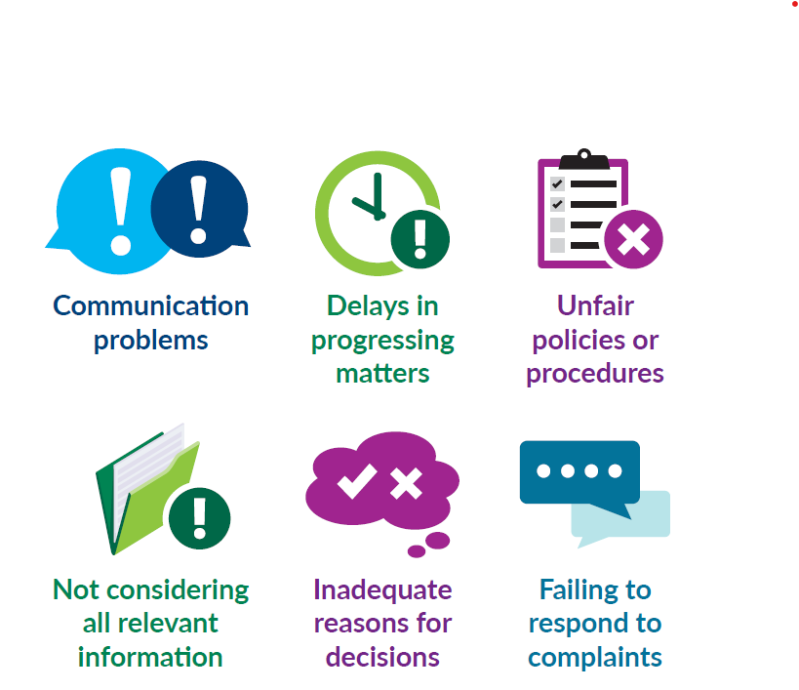

## What to expect

Our service charter sets out what to expect when engaging with our services, and what we expect from people making complaints.

We aim to address matters as quickly as possible while ensuring they are fully considered. We seek to:

* acknowledge receipt of a matter in three working days
* connect complainants with their case officer within 10 working days
* provide progress updates every six weeks for ongoing matters.

### Assessing complaints

When we receive a new complaint to the Ombudsman, our first step is to carefully consider the most appropriate way to assist.

We may decide to:

* transfer the complaint to the organisation being complained about for a response
* make preliminary inquiries
* start an investigation
* refer the complainant to an alternative organisation that may be better suited to addressing their concerns
* decide not to take any further action.

Find out more about our complaint handling processes on [our website](http://www.nhpo.gov.au) <www.nhpo.gov.au>.

### Investigating complaints

When we investigate a complaint, we review all available evidence to decide whether the organisation’s handling of a matter was:

* fair and reasonable
* consistent with relevant legislation and applicable policies and procedures.

We cannot consider whether a decision made by an organisation was right or wrong or make them change a decision.

### Creating positive change

We see complaints as an important way to not only resolve an individual’s concerns, but to identify and address problems that may be affecting others.

After assessing or investigating a complaint, we may:

* suggest that a process or policy be reviewed or changed
* provide (or suggest the organisation provides) a better explanation of a decision or action
* suggest the processing of a delayed matter be prioritised
* suggest an apology is provided
* suggest that a decision be reconsidered if a process followed in making the decision was unfair
* decide that the handling of the matter was reasonable and take no further action.

## Frequently asked questions

**Can you change a decision?**

We cannot force the organisation you have complained about to change a decision. However, when appropriate, the Ombudsman can request that the organisation re-consider a decision.

**How long will it take?**

We aim to finalise complaints in three to six months. More complex investigations may take between nine and twelve months. We provide complainants with a progress update every six weeks.

**Does it cost money to make a complaint?**

No. Our services are free, and we encourage all health practitioners and community members to share their concerns with us.

**Do you accept anonymous complaints?**

Yes. However, it may be difficult or impossible to investigate complaints without some identifying information. Where possible, we request anonymous complaints are made by phone so we can discuss these issues further.

**Can complaints be withdrawn?**

Yes. Once this request is made, we will advise the organisation that the complaint has been withdrawn and close the complaint unless we need to take further steps to prevent a serious threat.

**What about privacy breaches or FOI decisions?**

Find out more about complaints to the Commissioner and applications for review of Ahpra’s FOI decisions on our [website](http://www.nhpo.gov.au): <www.nhpo.gov.au>.

To receive this document in another format phone 1300 795 265, using the National Relay Service 13 36 77 if required, or [email](mailto:complaints@nhpo.gov.au) our complaints team [complaints@nhpo.gov.au](mailto:complaints@nhpo.gov.au).

Authorised and published by the National Health Practitioner Ombudsman, 50 Lonsdale St, Melbourne. © National Health Practitioner Ombudsman, Australia, January 2023.