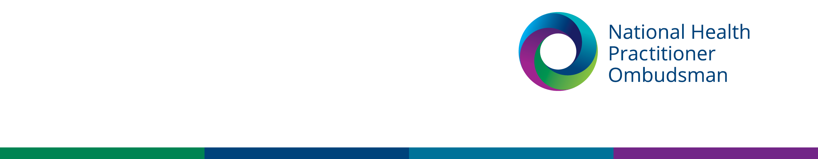

|  |
| --- |
| Media release |
| 8 November 2023 |

**National Health Practitioner Ombudsman’s annual report shows a 39 per cent increase in complaints about Ahpra’s notification process**

The office of the National Health Practitioner Ombudsman (NHPO)’s recently released [annual report](https://www.nhpo.gov.au/annual-report-2022-23) reveals it received 1,884 approaches in 2022–23, an 18 per cent increase compared with the previous financial year. This included 633 complaints to the National Health Practitioner Ombudsman and 1,183 enquiries.

In 2022–23 the Ombudsman’s office focused on making continuous systemic improvements in the Australian Health Practitioner Regulation Agency (Ahpra)’s notification and registration processes.

Complaints to the Ombudsman about the notification process increased by 39 per cent in 2022– 23 compared with 2021–22 (from 309 to 430 complaints).

Following ongoing feedback regarding communication and timeliness in the management of notifications about the health, conduct or performance of registered health practitioners, Ahpra adopted a new case management model in 2022–23.

The Ombudsman, Richelle McCausland, said that while she welcomed a general reduction in the time taken to manage notifications, there has been a significant increase in the number of issues raised with her office that:

* a decision made about a notification was unfair or unreasonable (from 153 issues in 2021–22 to 227 issues in 2022–23)
* the notifications process was unfair (from 46 issues in 2021–22 to 88 issues in 2022–23).

To date, the office has found Ahpra to be responsive to feedback and suggestions for improvement. However, the Ombudsman said her office continues to examine and monitor the effects of the new model and suggest appropriate remedies to identified issues.

The Ombudsman also highlighted the expansion of her office’s powers in relation to accreditation processes as a watershed moment of the financial year. The office can now consider complaints about the assessment of overseas-qualified practitioners by accreditation organisations, and the delivery of specialist medical colleges’ training programs.

“Australia’s health system continues to operate under increased pressure due to the ongoing effects of the COVID-19 pandemic. This gives impetus to ensuring processes supporting health practitioner regulation are fair, effective and efficient,” said the Ombudsman.

“My office provides a free and independent complaint service. Each complaint is important to us and can help us identify opportunities to improve the regulation of health practitioners for everyone.”

Complaints can be made by calling 1300 795 265, emailing [complaints@nhpo.gov.au](mailto:complaints@nhpo.gov.au) or visiting www.nhpo.gov.au.

**For more information, please contact our media team at** [**media@nhpo.gov.au**](mailto:media@nhpo.gov.au)**.**